**Lab Activities:**

**Part 1: Capturing HTTP Traffic with Filtering HTTP packets and analyze them**

Get Http:

### 

Response with 200 ok:

### 

**Part 2: Analyzing TCP/IP Traffic.**

**TCP** Stream:

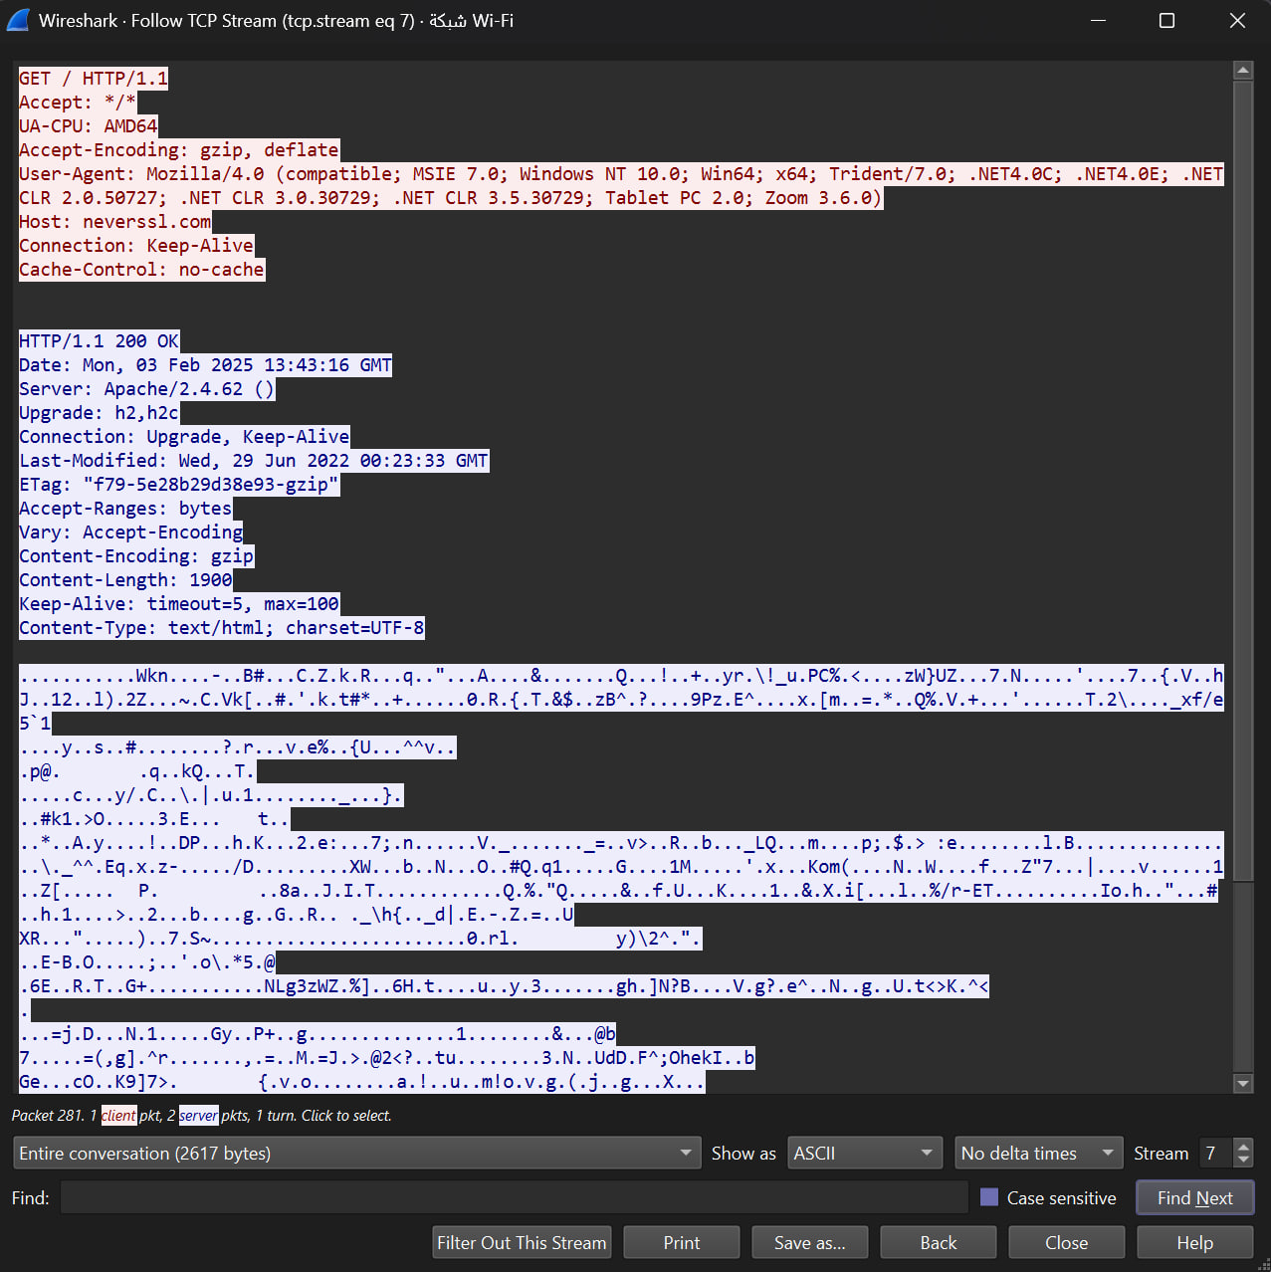

Analyzing **TCP** handshakeand investigate Data Transfer and Termination showing SYN, SYN-ACK, ACK, and FIN, ACK packets:

### 

**Part 3: Generate UDP traffic and capture, Filter and analysis The Packets.**

Showing the source and destination ports, length, and data:

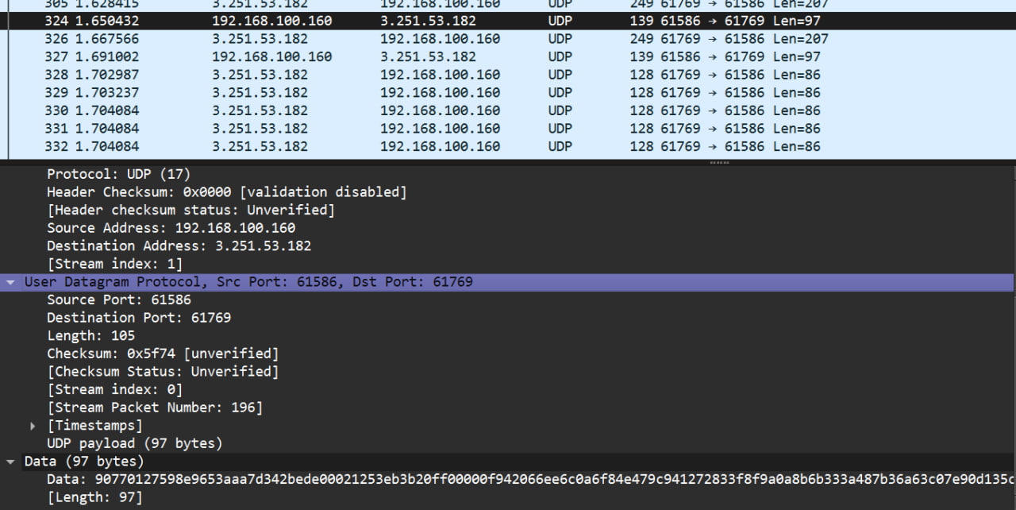

**Q. Compare the simplicity of UDP headers with TCP headers?**

**UDP headers are simpler (8 bytes),** while TCP headers are more complex, with more fields for connection and error handling.

**TCP** also requires a **three-way handshake** (SYN, SYN-ACK, ACK) to establish a connection.

**Part 4: Comparing TCP and UDP**

**Task1:Comparing between TCP and UDP with Reasons**

|  | **TCP or UDP** | **Reasons** |
| --- | --- | --- |
| Reliability and Connection Establishment | TCP | TCP establishes a connection before transmission, ensuring reliability and packet order |
| Data Integrity and Ordering | TCP | Ensures data integrity with error checking  and maintains the correct order of packets |

**Task2: Use Cases and Performance of TCP and UDP**

|  | **TCP** | **UDP** |
| --- | --- | --- |
| Use cases | Web browsing, email, file transfer,  SSH(Secure Shell) | Video streaming, gaming,  DNS(Domain Name System) |
| Performance | Slower because of the overhead and reliability mechanisms | Faster because there is lower overhead,  but it is unreliable |

**Remaz Muath Aloudah**

**421201869**